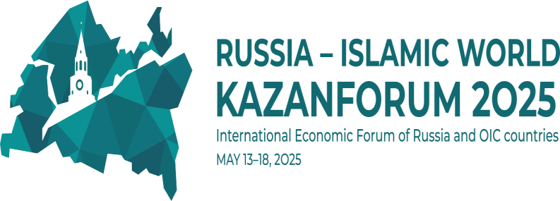

Program of the First International AAOIFI Conference on the topic:

"Partnership finance and investment: promoting sustainable

development and global partnership"

**Day 1: May 15, 2025**

|  |  |
| --- | --- |
| 09:00 – 10:00 | **Gathering of guests**  **Registration and networking** |
| 10:00 – 11:30 | **Opening Ceremony and Plenary Session**  Topic of the plenary session: "Using the potential of partnership finance in the economic development of the Russian Federation."  Invited guests:   * accredited conference participants; * authoritative international experts and representatives of international institutions; * heads of the constituent entities of the Russian Federation – participants in the experiment; * representatives of the CIS countries. |
| 11:30 - 13:00 | **Lunch and networking** |
| 13:00 – 14:30 | **Panel Session #1:**  **"Standardization of partnership financial activities"**  The session "Standardization of Partnership Financial Activities" will become a platform for discussing key aspects of standardization, including the development of uniform standards for accounting, audit, risk management and Sharia supervision. Participants will review best global practices, analyze the role of international organizations, such as AAOIFI, in the development and implementation of standards, and develop recommendations for creating a favorable regulatory environment for the development of partnership financing. The goal of the session: to develop practical approaches to standardizing partnership financial activities to improve their efficiency, transparency and compliance with international standards. |
| 14:30 – 15:00 | **Break / Coffee break** |
| 15:00 – 17:00 | **Panel Session #2:**  **"Opportunities for International Investment"**  The session "Opportunities for International Investment" is devoted to the analysis of promising areas and mechanisms for attracting international investment that meet the principles of partnership financing. During the session, experts will consider the potential of various sectors of the economy, such as infrastructure, agriculture, industry and the technology sector, to attract Islamic investment. Particular attention will be paid to the creation of a favorable investment climate, risk reduction and ensuring the transparency of investment processes. The goal of the session: to identify and discuss key opportunities for attracting international investment that meet the principles of partnership financing, and to develop recommendations for creating a favorable environment for their implementation. |
| 18:00 - 20:00 | **Gala reception on behalf of Rais of the Republic of Tatarstan** |

**Day 2: May 16, 2025**

|  |  |
| --- | --- |
| **Time** | **Type of activity** |
| 10:00 – 11:30 | **Panel Session #3:**  **"Education and training of personnel in the field of partnership financing"**  The session "Education and training of personnel in the field of partnership financing" is aimed at discussing key issues related to the formation of qualified specialists for the dynamically developing industry of partnership (Islamic) finance. The participants of the session will consider advanced practices in the field of education and training of personnel, as well as ways of their adaptation to Russian realities. Particular attention will be paid to attracting international experience and expertise, developing cooperation with leading educational centers, as well as creating a specialized infrastructure that contributes to improving the qualifications of specialists in the field of partnership finance. |
| 11:30 - 12:30 | **Lunch in the format of bilateral meetings / Juma - prayer** |
| 12:30 – 14:00 | **Seminar (Workshop) AAOIFI.**  The series of seminars (workshops), including "Basics of Islamic Financial Products", "Introduction to AAOIFI Standards" and "Getting to Know Sukuk", is designed to train specialists in the field of partner financing. The first seminar will present key Islamic financial products that comply with Shariah standards. The second seminar will introduce the basic principles and requirements of AAOIFI standards. The third seminar will focus on sukuk, Islamic bonds, their structure, types and regulatory features. The goal of all seminars is to develop practical skills and knowledge for successful work in the field of partner financing. |
| 14:00 - 14:30 | **Official signing ceremony of the KazanForum agreements** |
| 14:30 – 16:30 | **Plenary session of KazanForum: “Digital financial system as an alternative in the development of relations between Russia and OIC countries”.**  The experts of the plenary session will continue the topic mentioned at the BRICS summit on digitalization, since in the context of global economic changes and challenges facing the international community, it is becoming a key factor for strengthening cooperation between Russia and the states of the Organization of Islamic Cooperation (OIC).  During the meeting, speakers will discuss issues of implementation  innovative technologies in various sectors of the economy, will share successful examples of the implementation of digital projects, as well as interstate partnership and exchange of experience. The prospects for creating unified digital platforms for interaction between countries will be considered. Considerable attention will be paid to new opportunities for international cooperation in this area between Russia and the OIC countries. |